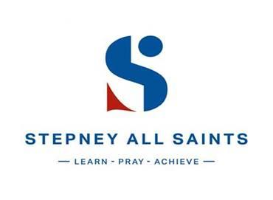

A Level Biology
Transition pack

“Whenever you feel sad, just remember that there are trillions of cells in your body and all they care about is you.”
JarOfQuotes.com

A Level Biology
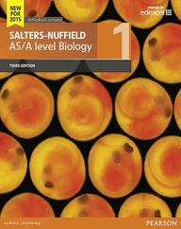
A guide to help you get ready for A-level Biology, including everything from topic guides to online learning resources.

At A Level, we study Edexcel A.
The course includes three exam papers (each weighing 33.3%) on the following topics:
● Topic 1: Lifestyle, Health and Risk
● Topic 2: Genes and Health
● Topic 3: Voice of the Genome
● Topic 4: Biodiversity and Natural Resources
● Topic 5: On the Wild Side
● Topic 6: Immunity, Infection and Forensics.
● Topic 7: Run for your Life
● Topic 8: Grey Matter.

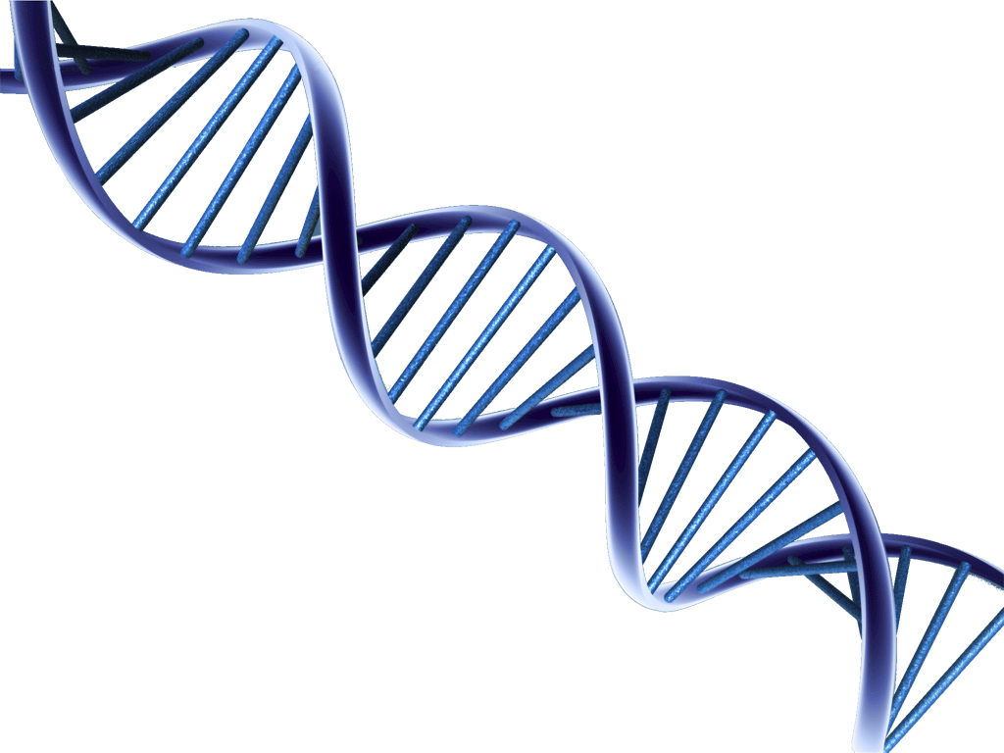
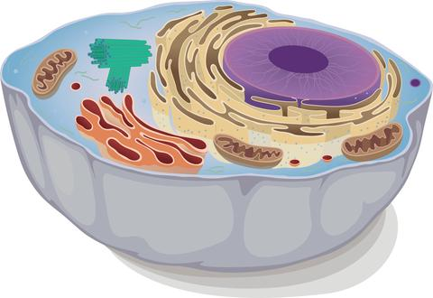

Pre-Knowledge Topics – Week 1
A level Biology will use your knowledge from GCSE and build on this to help you understand new and more demanding ideas. Complete the following tasks to make sure your knowledge is up to date and you are ready to start studying:

Cells – Week 1
The cell is a unifying concept in biology; you will come across it many times during your two years of A level study. Prokaryotic and eukaryotic cells can be distinguished on the basis of their structure and ultrastructure. In complex multicellular organisms cells are organised into tissues, tissues into organs and organs into systems. During the cell cycle genetic information is copied and passed to daughter cells. Daughter cells formed during mitosis have identical copies of genes while cells formed during meiosis are not genetically identical
Read the information on these websites (you could make more Cornell notes if you wish):
http://www.s-cool.co.uk/a-level/biology/cells-and-organelles
http://www.bbc.co.uk/education/guides/zvjycdm/revision
And take a look at these videos:
https://www.youtube.com/watch?v=gcTuQpuJyD8
https://www.youtube.com/watch?v=L0k-enzoeOM
https://www.youtube.com/watch?v=qCLmR9-YY7o
Task:
Produce a two-three pages revision guide to share with your class in September summarising one of the following topics: Cells and Cell Ultrastructure, Prokaryotes and Eukaryotes, or Mitosis and Meiosis.
Whichever topic you choose, your revision guide should include:
Key words and definitions
Clearly labelled diagrams
Short explanations of key ideas or processes.

Biological Molecules – Week 1
Biological molecules are often polymers and are based on a small number of chemical elements. In living organisms carbohydrates, proteins, lipids, inorganic ions and water all have important roles and functions related to their properties. DNA determines the structure of proteins, including enzymes. Enzymes catalyse the reactions that determine structures and functions from cellular to whole-organism level. Enzymes are proteins with a mechanism of action and other properties determined by their tertiary structure. ATP provides the immediate source of energy for biological processes.
Read the information on these websites (you could make more Cornell notes if you wish):
http://www.s-cool.co.uk/a-level/biology/biological-molecules-and-enzymes
http://www.bbc.co.uk/education/guides/zb739j6/revision
And take a look at these videos:
https://www.youtube.com/watch?v=H8WJ2KENlK0
http://ed.ted.com/lessons/activation-energy-kickstarting-chemical-reactions-vance-kite
Task:
Krabbe disease occurs when a person doesn’t have a certain enzyme in their body. The disease effects the nervous system. Write a letter to a parent or a sufferer to explain what an enzyme is.
Your letter should:
Describe the structure of an enzyme
Explain what enzymes do inside the body with named examples
Include the idea of the lock and key model
Denaturation and its implications
Pre-Knowledge Topics – Week 2
DNA and the Genetic Code – week 2
In living organisms nucleic acids (DNA and RNA have important roles and functions related to their properties. The sequence of bases in the DNA molecule determines the structure of proteins, including enzymes.
The double helix and its four bases store the information that is passed from generation to generation. The sequence of the base pairs adenine, thymine, cytosine and guanine tell ribosomes in the cytoplasm how to construct amino acids into polypeptides and produce every characteristic we see. DNA can mutate leading to diseases including cancer and sometimes anomalies in the genetic code are passed from parents to babies in disease such as cystic fibrosis, or can be developed in unborn foetuses such as Downs Syndrome.
Read the information on these websites (you could make more Cornell notes if you wish):
http://www.bbc.co.uk/education/guides/z36mmp3/revision
http://www.s-cool.co.uk/a-level/biology/dna-and-genetic-code
And take a look at these videos:
http://ed.ted.com/lessons/the-twisting-tale-of-dna-judith-hauck
http://ed.ted.com/lessons/where-do-genes-come-from-carl-zimmer
Task:
Produce a wall display to put up in your classroom in September. You might make a poster or do this using PowerPoint or similar your display should use images, keywords and simple explanations to:
Define gene, chromosome, DNA and base pair
Describe the structure and function of DNA and RNA
Explain how DNA is copied in the body
Outline some of the problems that occur with DNA replication and what the consequences of this might be.

Pre-Knowledge Topics – Week 3
Evolution – week - 3
Transfer of genetic information from one generation to the next can ensure continuity of species or lead to variation within a species and possible formation of new species. Reproductive isolation can lead to accumulation of different genetic information in populations potentially leading to formation of new species (speciation). Sequencing projects have read the genomes of organisms ranging from microbes and plants to humans. This allows the sequences of the proteins that derive from the genetic code to be predicted. Gene technologies allow study and alteration of gene function in order to better understand organism function and to design new industrial and medical processes.
Read the information on these websites (you could make more Cornell notes if you wish):
http://www.bbc.co.uk/education/guides/z237hyc/revision/4
http://www.s-cool.co.uk/a-level/biology/evolution
And take a look at these videos:
http://ed.ted.com/lessons/how-to-sequence-the-human-genome-mark-j-kiel
http://ed.ted.com/lessons/the-race-to-sequence-the-human-genome-tien-nguyen
Task:
Produce a two-three page revision guide for an AS Biology student that recaps the key words and concepts in this topic. Your revision guide should:
Describe natural selection and speciation
Explain what a genome is
Give examples of how this information has already been used to develop new treatments and technologies.
Include diagrams to illustrate your points

