Step Up to Law - A Level

Welcome to Law!

An A level in Law will open the doors to many different areas of future education and careers.
Your studies will equip you with key skills of analysis, synthesis and evaluation that you will be able to apply to your other subjects and beyond.

The purpose of this booklet is for you to start to explore some of the content and issues that form the basis of our legal system within the UK. You will then be able to understand some of the key institutions that underpin our legal system, as well as critically consider topical issues to do with law and justice that we will continue to look at in year 12.

This booklet has been divided into a three-week structure to allow you the opportunity to explore the topics and issues covered in year 12:

Week | Topics
Week 1 | Parliamentary Law Making – Legislation
Week 2 | Bail
week 3 | Sentencing

A level Law - WJEC Eduqas

The specification has three components:
● Component 1: The Nature of Law and the English Legal System
● Component 2: Substantive Law in Practice
● Component 3: Perspectives of Substantive Law

Week 1: | Parliamentary Law Making – Legislation

Task 1: How a bill turns into a law
.

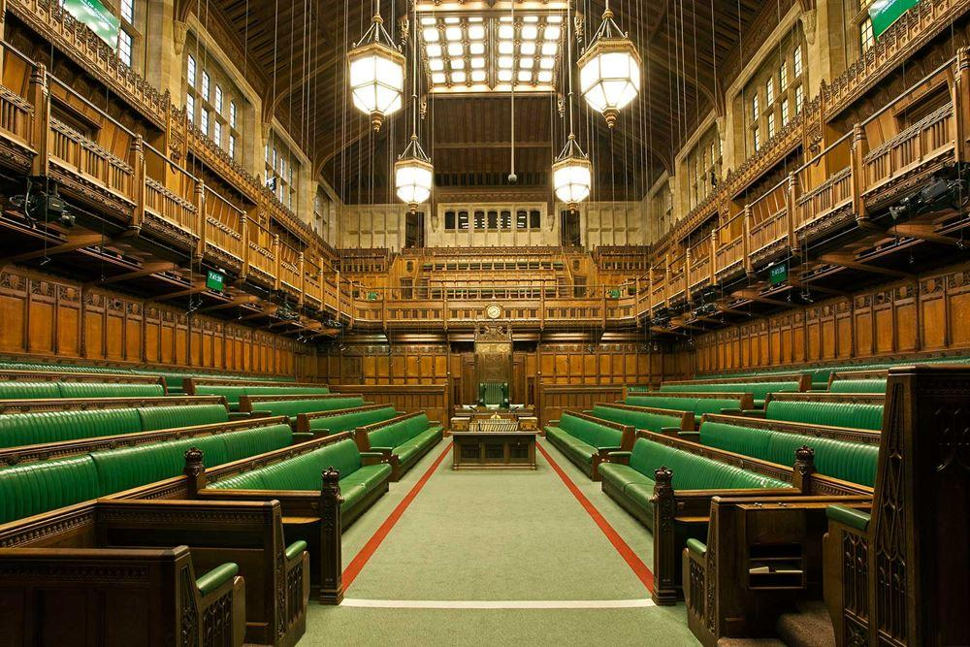

Watch the following video clips to understand who, where and how we make laws in the UK

https://www.parliament.uk/about/how/role/

https://www.youtube.com/watch?v=1KFGt9M-j28

https://www.parliament.uk/about/how/laws/

Then sort the statements below; decide on the correct order to complete a flow chart that describes the how an Act of Parliament is made

● Second Reading – proposals fully debated – MPs vote whether to proceed
● Committee Stage – detailed examination – amendments can be made.
● House of Lords – Bill then goes to the Lords – goes through similar process as the Commons, any amendments must go back to Commons for consideration
● First Reading – title is read to the House of Commons
● Report Stage – Committee reports back to the House, vote is taken.
● Third Reading – Bill re-presented to the House - vote taken
● Royal Assent

Stages of a Bill - flow chart

Task 2 – The functions of parliament and evaluation

Read through the article below to focus on the functions of parliament and the relevant evaluation.

https://www.tutor2u.net/politics/blog/revision-update-parliament-evaluation-of-the-legislature

You now need to you analyse the advantages and disadvantages of the legislative process and present your understanding in the form of a table below.
Remember your evaluation should be focused on whether parliament is able to fulfil its functions well.

Point (Advantage/Disadvantage) | Explanation

What concluding comments can you make about whether parliament is fit for purpose? Does it do a good job of carrying out its functions?

Week 2: | Bail

Task 1: Risks associated with bail

Read the statements below, and explain in more detail why they may be reasons to refuse bail.
You may need to carry out some independent research to understand these reasons better.

Reason | Explanation
D would fail to surrender to custody

D would commit an offence whilst on bail

D would interfere with witnesses or otherwise obstruct the course of justice

D needs to be kept in custody for his own protection

Task 2: Conditions of bail

Sometimes the police and courts are able to impose what is known as conditions to limit risks to bail.

Read the conditions and explain why they would be suitable conditions to impose on the defendant when granting bail – what would the condition prevent them from doing?

Condition | Why it is a suitable condition to impose upon a defendant
Curfew/Tagging

Surrender of passport

Reporting to police station at regular intervals

Residing at a bail hostel

Surety

Task 3 – Should bail be granted?

Jack is an ex-police officer. Recently he has been arrested for domestic violence offences, however, since leaving the police force, he had also previously been arrested for other non-fatal offences such as assault and ABH. Jack has close links to his old police friends and all his family currently reside within the UK, however he owns a holiday home in the Caribbean.

Decide whether to grant Jack bail or refuse bail.
You need to outline your reasons; and discuss whether any conditions would be appropriate.
What is your final conclusion?

Week 3: | Sentencing

The aim of this session is to explore the different ways of disposing of criminal cases.
You will need to understand the theories of punishment first, but then you will understand the importance of out of court disposals as a more recent method and process of dealing with sentencing.

Use the link below to read through pages 1-2 only.
https://www.bbc.co.uk/bitesize/guides/zvs3d2p/revision/1

Task 1: Theories of punishment

Develop your own definitions for these 5 theories

● Deterrence

● Reformation

● Protection

● Retribution

● Reparation

Find appropriate examples of sentences/punishments that are examples of the above theories of punishments
● Deterrence
● Reformation
● Protection
● Retribution
● Reparation
Task 2: Sentencing – debate it

Read through the articles below.

https://www.lawgazette.co.uk/news/criminal-bar-warns-of-disturbing-rise-in-informal-police-sanctions/5104364.article

https://www.telegraph.co.uk/news/2020/05/23/controversial-community-resolution-orders-increasingly-used/

https://www.thenorthernecho.co.uk/news/17709901.pros-cons-police-using-court-disposals/

https://www.independent.co.uk/news/uk/crime/crime-justice-system-criminal-record-low-new-prosecution-england-wales-statistics-a9202506.html

Using the information from the articles, formulate arguments in relation to the statement below;

‘There is no substitute for imprisonment. It ensures that those who commit crime
are punished and it also acts as a deterrent.’ Discuss.

Arguments in favour of the statement | Arguments against the statement

Comment:
What are your thoughts in relation to whether prison is the best/most effective method of dealing with those who choose to commit crimes? Present a balanced response.

