A Level Physics
Handbook

“The important thing is not to stop questioning. Curiosity has its own reason for existing.”
Albert Einstein

Transition Pack for A Level Physics
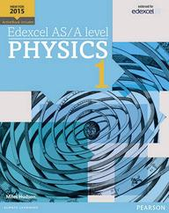
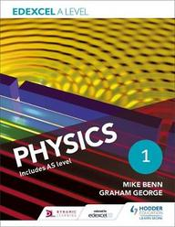
A guide to help you get ready for A-level Physics, including everything from topic guides to online learning resources.

At A Level, we study Edexcel.
The course includes three exam papers on the following topics:
- Mechanics
- Electric Circuits
- Electric and Magnetic Fields
- Nuclear and Particle Physics
- Materials
- Wave and Particle Nature of Light
- Thermodynamics
- Space
- Nuclear Radiation
- Gravitational Fields
- Oscillations
- Working as a Physicist
There will be a minimum of 40% of questions across all three exams which require maths, including topics such as:
- Rearranging and substituting equations
- Logarithms and exponentials (AS Maths)
- Straight line graphs
- Trigonometry
- Vectors
- Proofs
You will also complete numerous core experiments relating to topics you learn as part of the course and learn associated data analysis techniques.

Physics Teachers
Mr Ahmad – Jubair.ahmad@stepneyallsaints.school
Mr Iqbal – Imran.iqbal@stepneyallsaints.school
Mr Momin - jamal.momin@stepneyallsaints.school

Ask for us at the science office on the 4th floor.

Year 12 Map
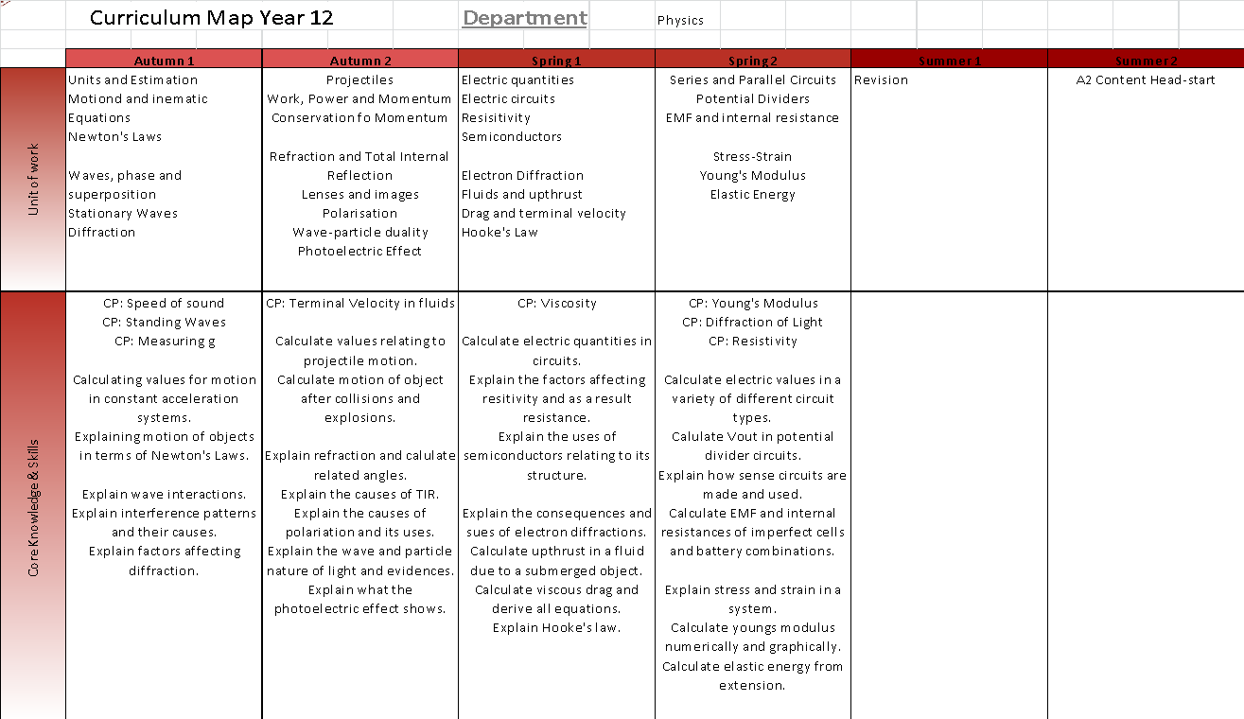
Year 13 Map
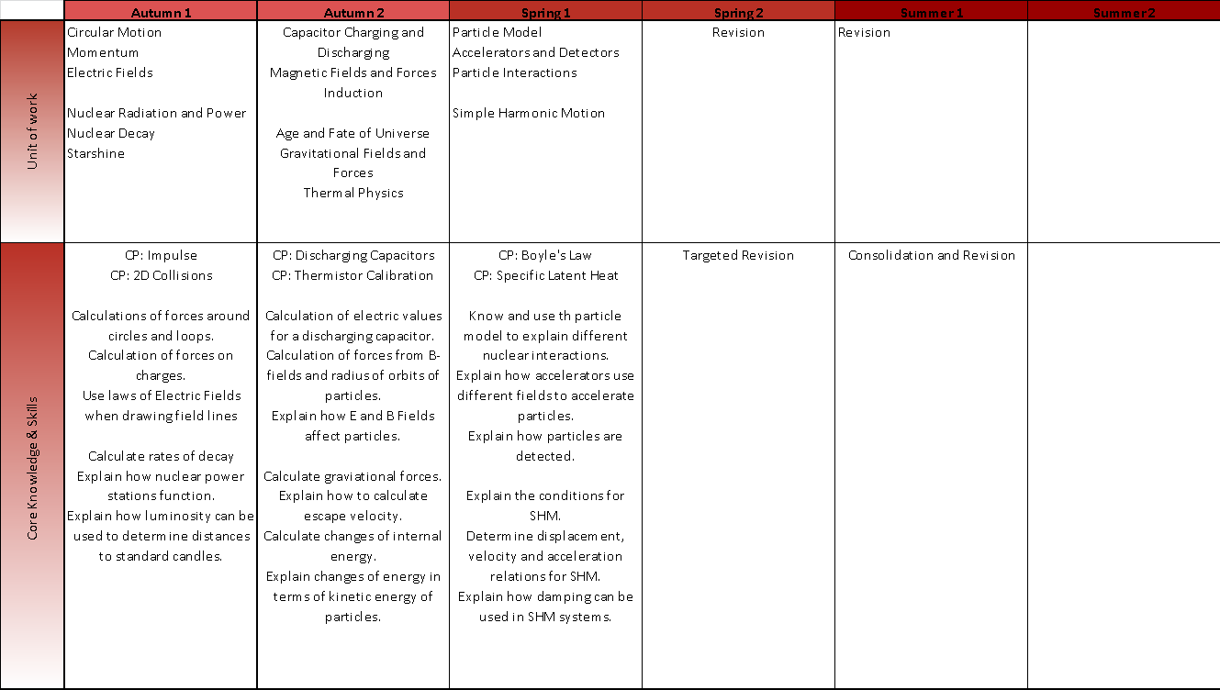
The full specification can be found in the Pearson Edexcel Website as well as exam papers and mark schemes.
Additional resources can also be found at the Physics and Maths Tutor website.
Pre-Knowledge Topics – Week 1

A level Physics will use your knowledge from GCSE and build on this to help you understand new and more demanding ideas. Complete the following tasks to make sure your knowledge is up to date and you are ready to start studying:

Research
To get the best grades in A Level Physics you will have to get good at completing independent research and making your own notes on difficult topics. Below are links to 5 websites that cover some interesting Physics topics.
Using the Cornell notes system: http://coe.jmu.edu/learningtoolbox/cornellnotes.html make 1 page of notes from any two of the websites below covering a topic of your choice.
http://home.cern/about
CERN encompasses the Large Hadron Collider (LHC) and is the largest collaborative science experiment ever undertaken. Find out about it here and make a page of suitable notes on the accelerator.
http://joshworth.com/dev/pixelspace/pixelspace_solarsystem.html
The solar system is massive and its scale is hard to comprehend. Have a look at this award winning website and make a page of suitable notes.
https://phet.colorado.edu/en/simulations/category/html
PhET create online Physics simulations when you can complete some simple experiments online. Open up the resistance of a wire html5 simulation. Conduct a simple experiment and make a one page summary of the experiment and your findings.
http://climate.nasa.gov/
NASA’s Jet Propulsion Laboratory has lots of information on Climate Change and Engineering Solutions to combat it. Have a look and make notes on an article of your choice.

Rearrange the following to make the desired letter the subject:
E=m x g x h to find h
Q= I x t to find I
E = ½ m v² to find m
E = ½ m v² to find v
v = u + at to find u
v = u + at to find a
v² = u² +2as to find s
v² = u² +2as to find u
Rearrange the following:
Write 2530 in standard form.
Write 280 in standard form.
Write 0.77 in standard form.
Write 0.0091 in standard form.
Write 1 872 000 in standard form.
Write 12.2 in standard form.
Write 2.4 x 10 ² as a normal number.
Write 3.505 x 10 ¹ as a normal number.
Write 8.31 x 10 ⁶ as a normal number.
Write 6.002 x 10 ² as a normal number.
Write 1.5 x 10⁻⁴ as a normal number.
Write 4.3 x 10³ as a normal number.
Give to 3 significant figures:
3.4527
40.691
0.838991
1.0247
59.972
Pre-Knowledge Topics – Week 2

Atomic Structure
You will study nuclear decay in more detail at A level covering the topics of radioactivity as well as particle physics. In order to explain what happens you need to have a good understanding of the model of the atom. You need to know what the atom is made up of, relative charges and masses and how sub atomic particles are arranged.

The following video explains how the current model was discovered www.youtube.com/watch?v=wzALbzTdnc8

Describe the model used for the structure of an atom including details of the individual particles that make up an atom and the relative charges and masses of these particles.

Explain the observations and subsequent conclusions made from Rutherford’s experiment.

Research Bohr’s model of the atom. Compare Bohr’s model to Rutherford’s model.

Research the subatomic structure of the atom within the nucleus. Identify the quark structure of a proton and a neutron.

Forces and Motion
At GCSE you studied forces and motion and at A level you will explore this topic in more detail so it is essential you have a good understanding of the content covered at GCSE. You will be expected to describe, explain and carry calculations concerning the motion of objects. The websites below cover Newton’s laws of motion and have links to these in action.
http://www.physicsclassroom.com/Physics-Tutorial/Newton-s-Laws
http://www.sciencechannel.com/games-and-interactives/newtons-laws-of-motion-interactive/
Write out Newton’s laws of motion.
Give an example for a scenario for each of Newton’s laws.
Explain the difference between balanced forces and an action-reaction pair.
Sketch a velocity-time graph showing the journey of a skydiver after leaving the plane to reaching the ground.
Mark on your graph where terminal velocity has been reached.
Explain the forces acting when terminal velocity has been reached.

Pre-Knowledge Topics – Week 3
Waves
You have studied different types of waves and used the wave equation to calculate speed, frequency and wavelength. You will also have studied reflection and refraction.
Use the following links to review this topic.
http://www.bbc.co.uk/education/clips/zb7gkqt
https://www.khanacademy.org/science/physics/mechanical-waves-and-sound/mechanical-waves/v/introduction-to-waves
https://www.khanacademy.org/science/physics/mechanical-waves-and-sound/mechanical-waves/v/introduction-to-waves
Describe the difference between a longitudinal and transverse waves and give an example of each
Draw a transverse wave and label the wavelength and amplitude
Draw a diagram showing the refraction of a wave through a rectangular glass block. Explain why the ray of light takes this path.
Explain the conditions required for total internal reflection.
After research, explain how seismic waves have allowed us to determine the inner structure of the Earth.
Research the evidence for light being a wave was well as evidence for light being a particle.
Research evidence for all particles behaving as waves or having wavefunctions.

