Step Up to Politics A Level

at Stepney All Saints School

Welcome to Politics A-level at Stepney All Saints!
The purpose of this booklet is for you to start gaining an understanding of the many complex issues which we face in the world today and how the UK responds to them. By the end of this series you should start to think about, and perhaps question, the institutions and organisations that form part of our political landscape and the role YOU can play in making a change.
We look forward to seeing you in Year 12 when we explore all these issues further.

Your work will be divided across three key areas:

Week | Topic
Week 1 | UK Political Parties
Week 2 | Voting and elections
Week 3 | Prime Ministers and Political Institutions

A Level Politics Specification
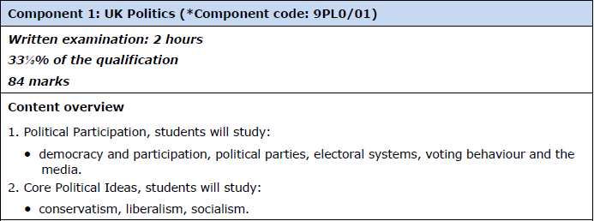
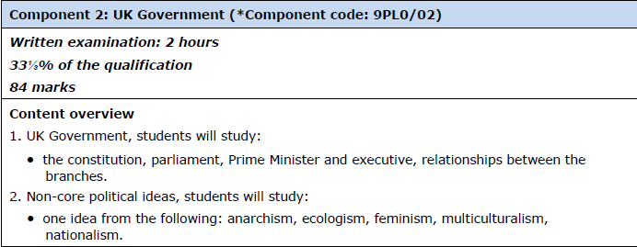
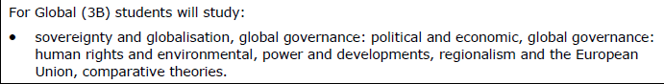

Week 1 – UK Political Parties
Task 1:
Who is your local Member of Parliament?
Which constituency does your MP represent?
What political party does your MP represent in Parliament?
Follow your MP’s political party over the next week and create a big poster containing news reports about your chosen political party. Make sure you include:
- The name of the leader of this party – include a photograph
- Newspaper clippings of political stories linked to your chosen party
- Look at how one story is represented in different media outlets. Follow the story in newspapers, the internet and on television. Do you notice any differences?

Task 2:
Follow a second political party (not the one your MP represents) over the next week and create a big poster containing news reports about your chosen political party. Make sure you include:
- The name of the leader of this party – include a photograph
- Newspaper clippings of political stories linked to your chosen party
- Look at how one story is represented in different media outlets. Follow the story in newspapers, the internet and on television. Do you notice any differences?

Suggested areas to help research:
- Broadsheet Newspapers: The Times, The Guardian, The Telegraph, The Financial Times and The Independent.
- Magazines: Private Eye, The Week, The Spectator, The New Statesman
- Television: Channel 4 News (with Jon Snow), BBC News, News Night, Question Time
- The Internet :
The Guardian website: http://www.theguardian.com/uk
BBC News website http://www.bbc.co.uk/news/
The Telegraph website http://www.telegraph.co.uk/
Step it up: Compare the coverage of the two parties. What similarities and differences do you notice and from which sources? What may be the reason behind this?

Week 3

Week 2
Task 3
Look at the website” Votes at 16” and write:
- 100 word statement why the voting age should be lowered
- 100 word statement why the voting age should stay the same

Step it up: Research more upon this topic and come up with a judgement why you think the voting age has still not changed

Task 2
Use the following website to answer the questions below:
https://www.bbc.co.uk/news/election/2019/results
Democracy and Participation
1. What was turnout in the election?
2. How did youth turnout compare to the last General Election?
3. Which areas had the highest turnout and why was this the case?
4. Despite the fact that turnout was better than in previous years, why was it still disappointing?
5. Give an example if an area where turnout was particularly low. What may have been the reason for this?

Step it up: Compare your findings to a second election of your choice (BBC website). What are the key differences?

Week 3
Task 1
Compare a Pre-1997 PM to a Post-1997 PM. What were the pivotal differences during their time in post?

In order to complete this task, you will need to make profiles upon two of the following Prime Ministers.
Theresa May, David Cameron, Tony Blair, Margret Thatcher, John Major, James Callaghan

Be sure to include the information below for each.
- Political Party
- Dates in office
- Previous posts
- Background
- Key policies
- Legacy/key achievements/controversies

Task 2
Under take a virtual tour the UK Supreme Court or Houses of Parliament.
Compare the UK institution with an equivalent system abroad. What are the key similarities and differences?
Write your response in a 500 word summary
Be sure to include:
- When it was founded.
- Who are the members?
- What are their roles?
- Brief history of key changes.
Which institution do you believe to be better and why?

